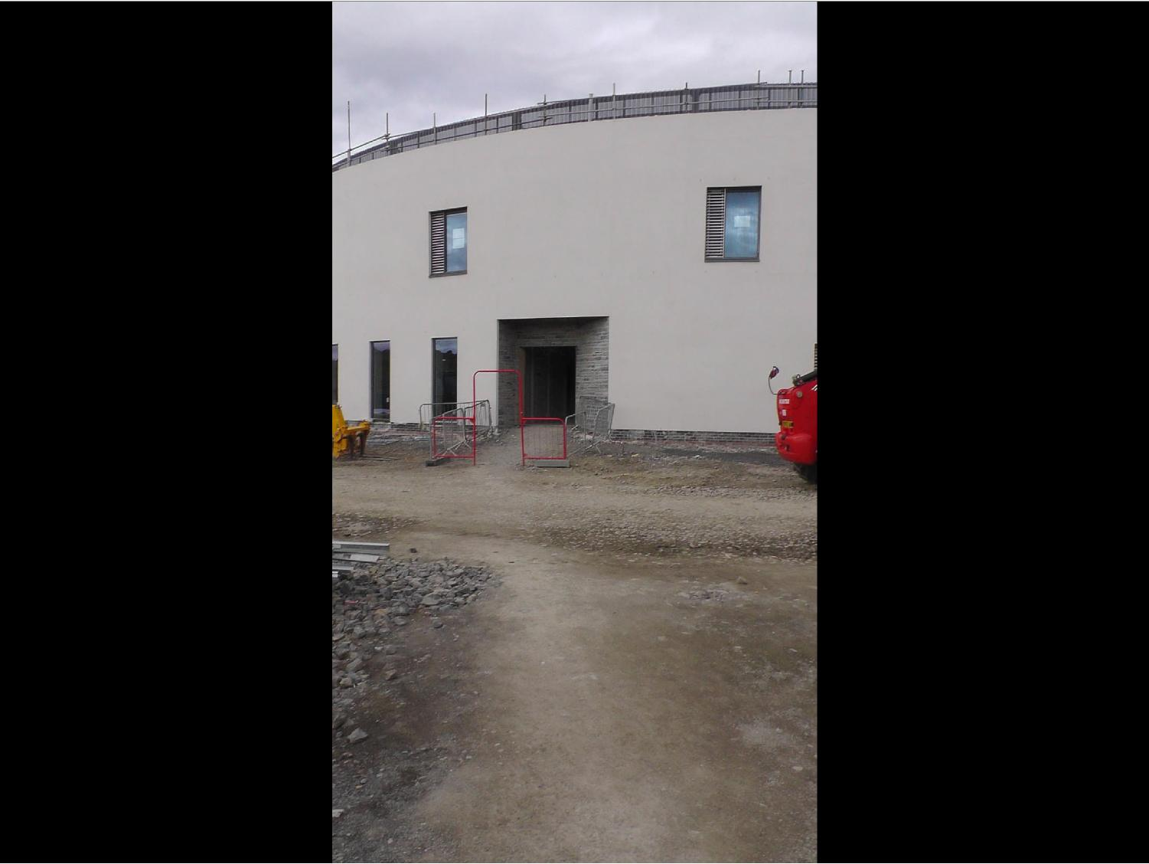

**Dialysis Entrance**

**August 2018**

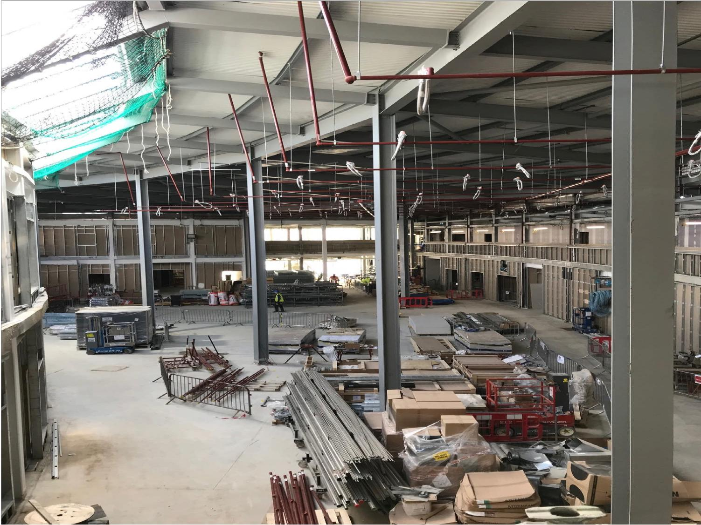

**Main Entrance and Hub Space**

**August 2018**

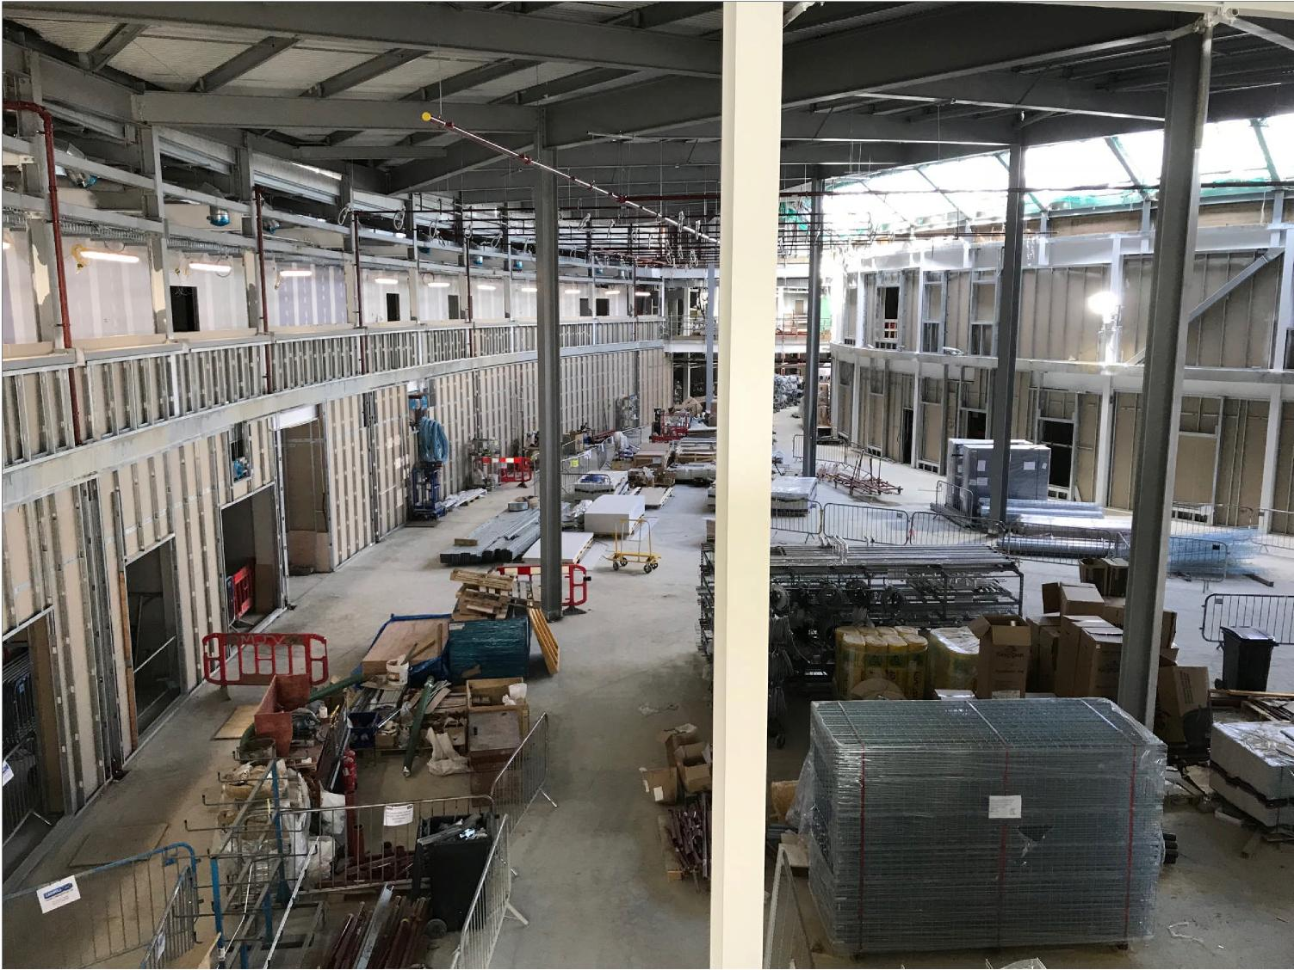

**View Towards Sanctuary,**

**Medical Records Dept and**

**Restaurant Area (All on Ground**

**Floor)**

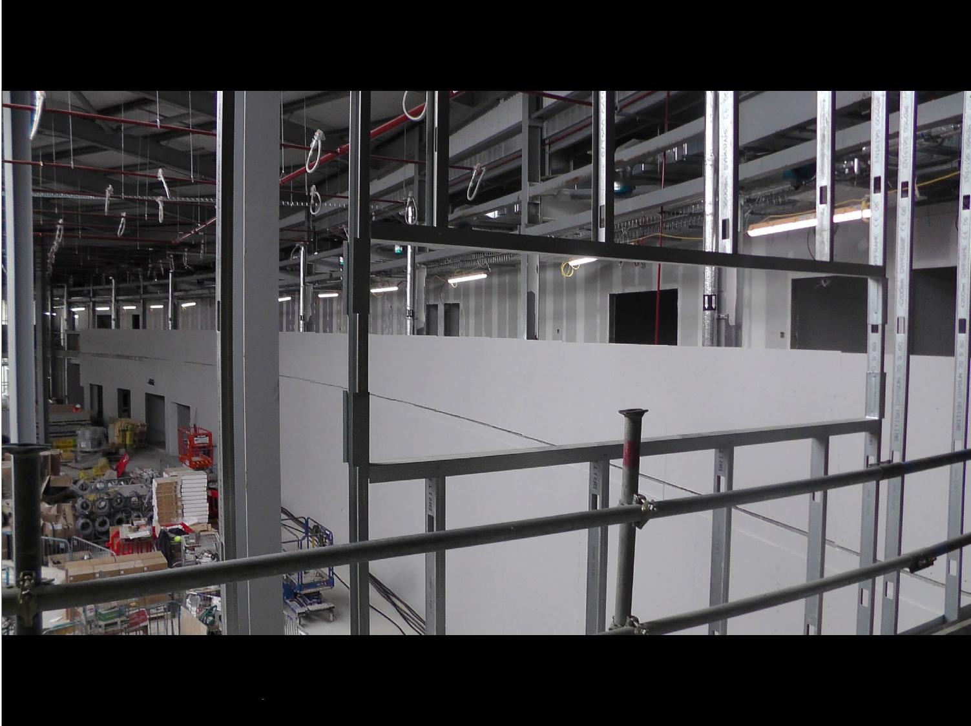

View Across to Inpatient Ward Corridor – Corridor Walls Under Construction

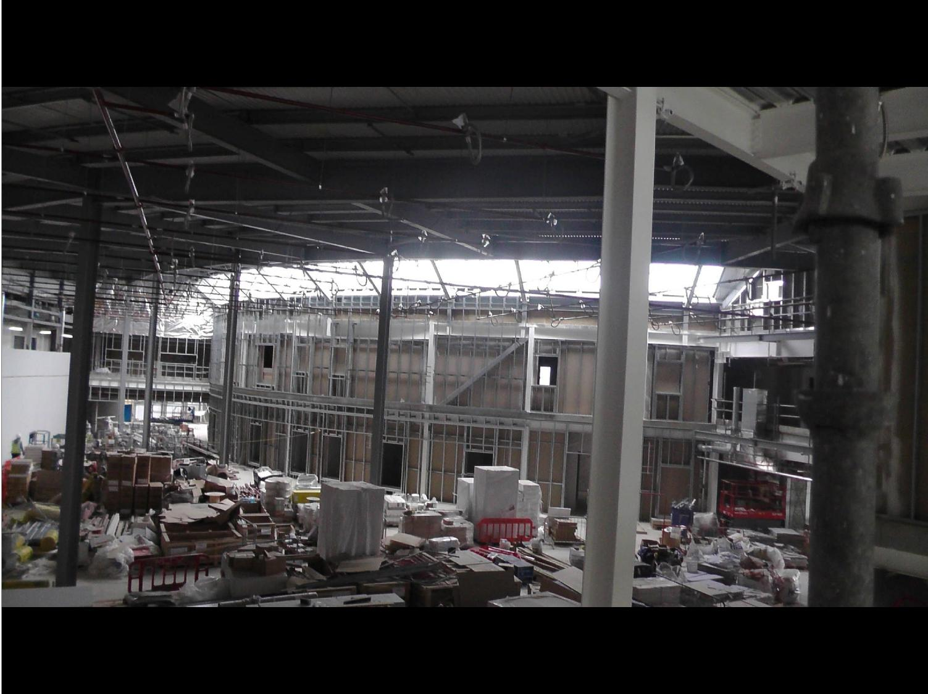

**Hub Space and Skylight**

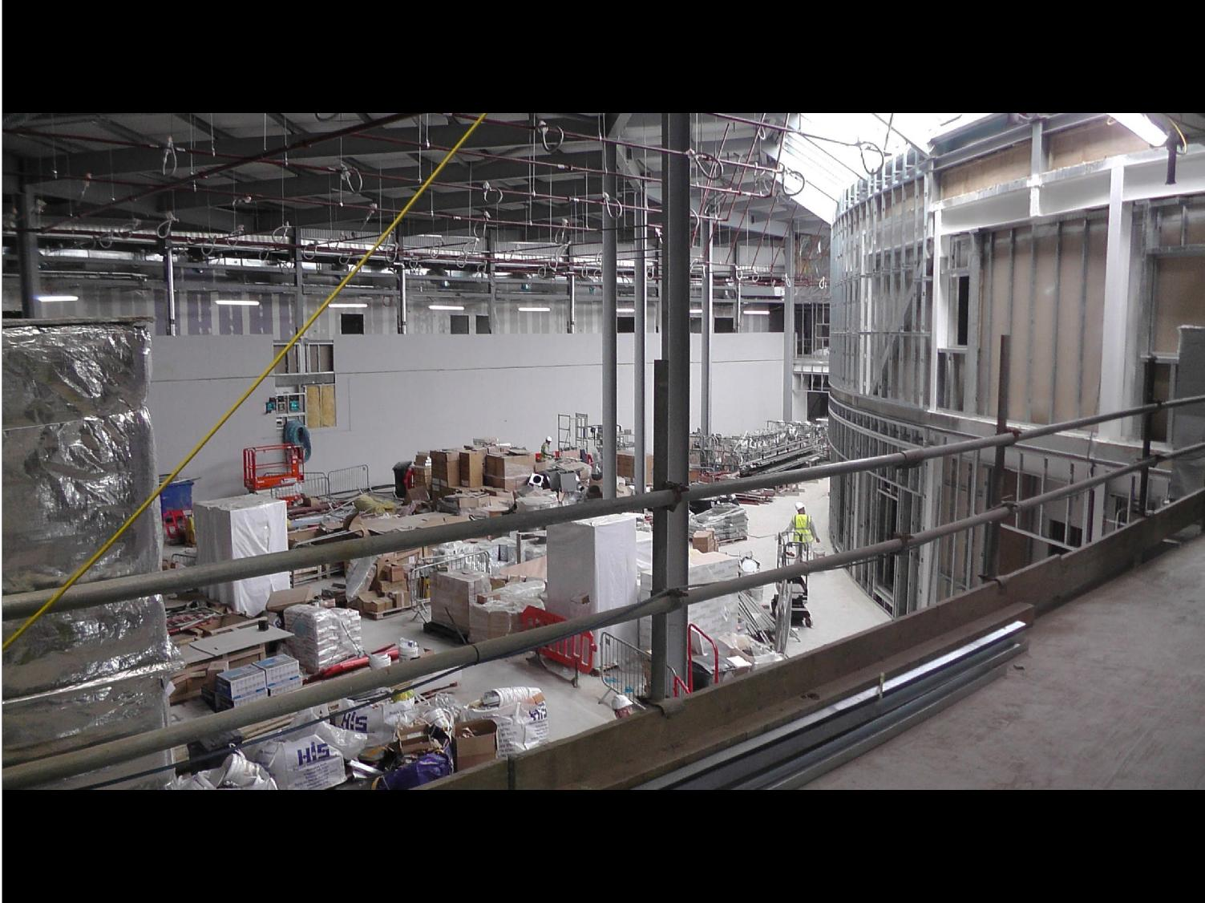

**View From Link Corridor**

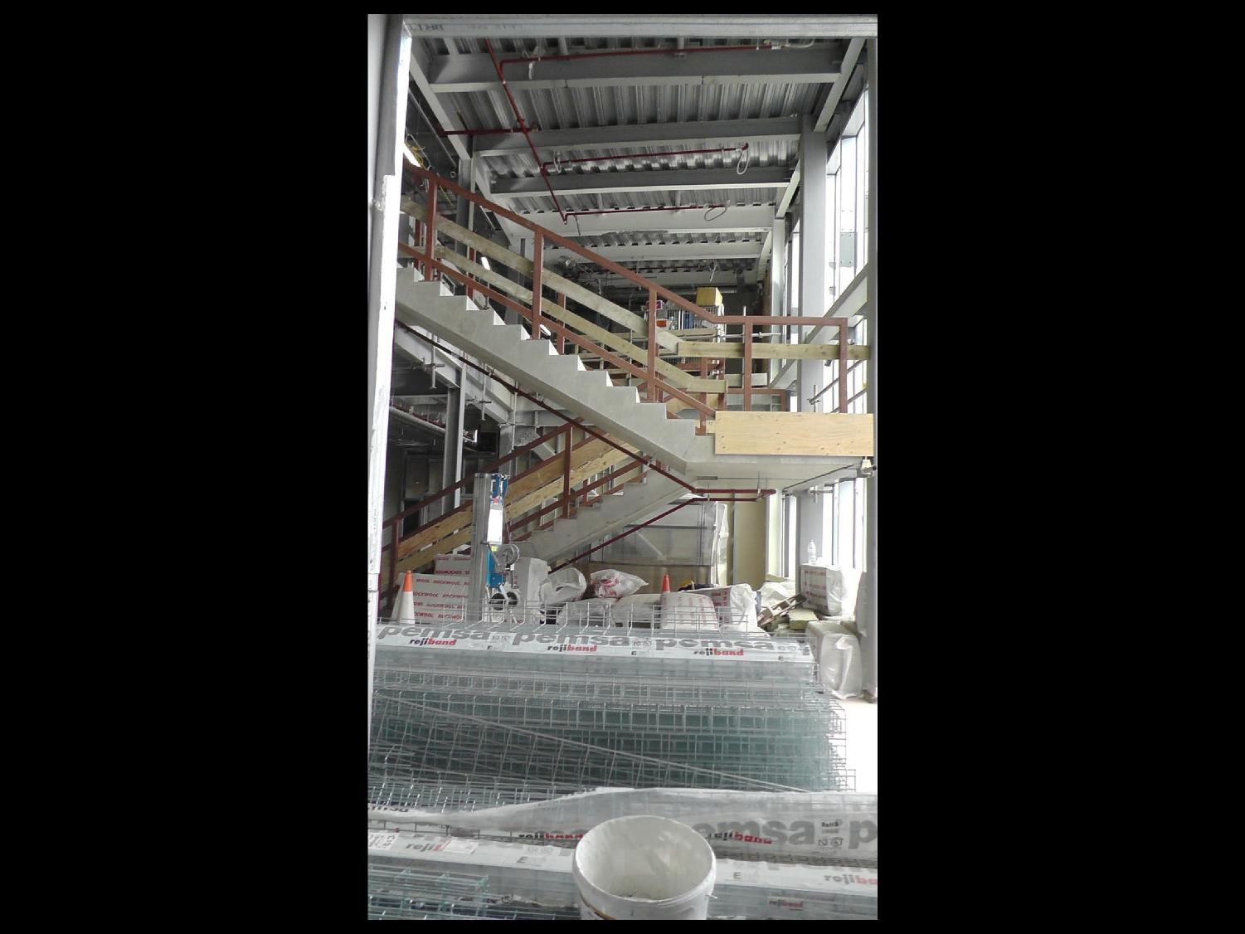

**Staircase**

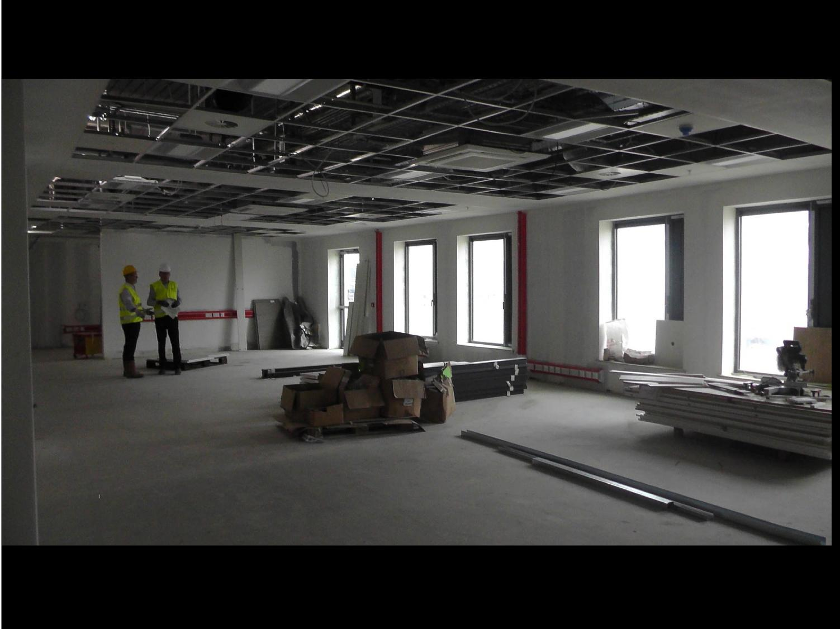

**Clinical Support Building**

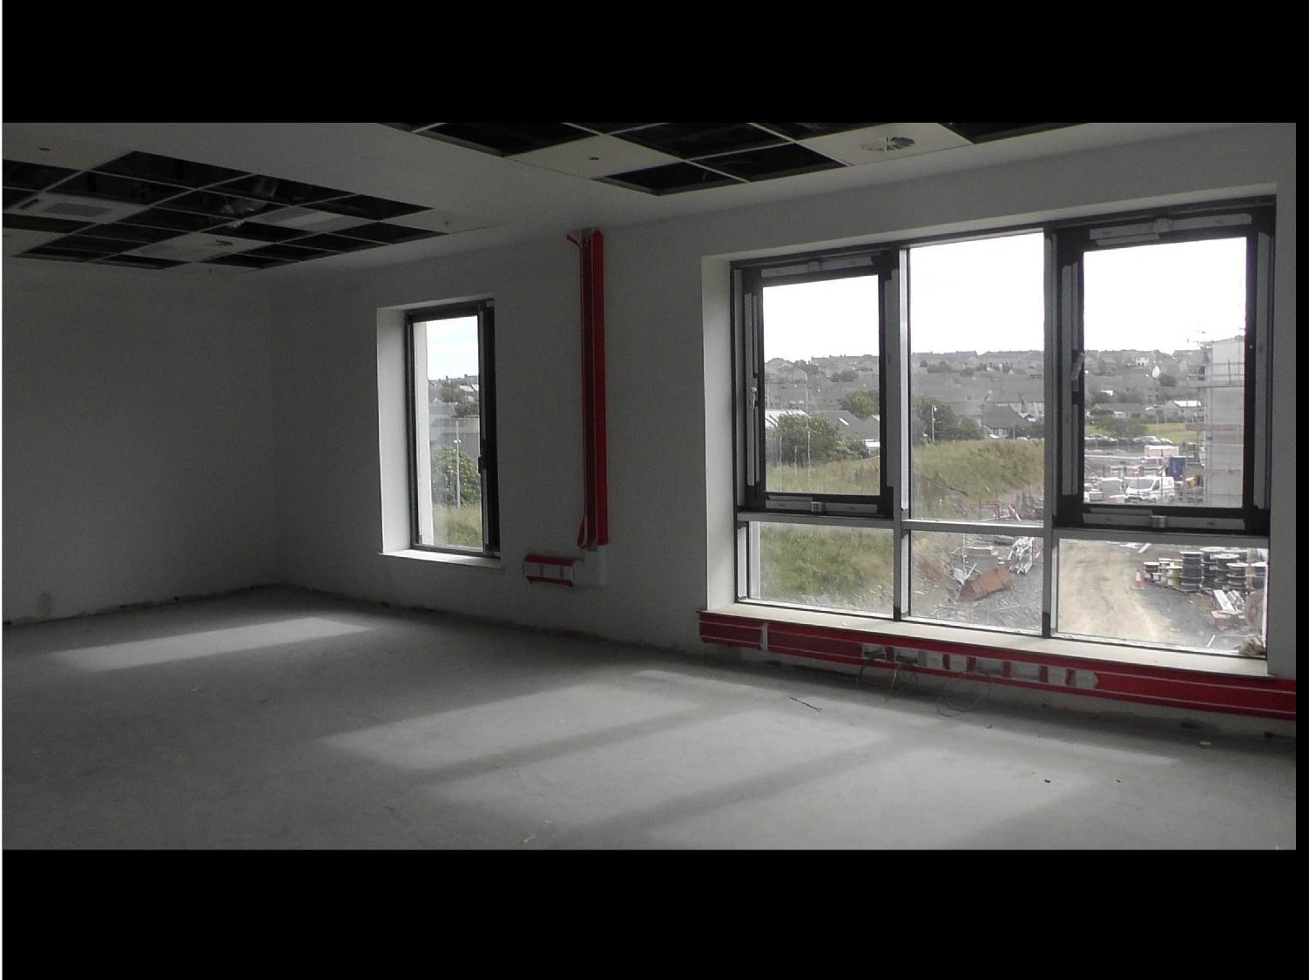

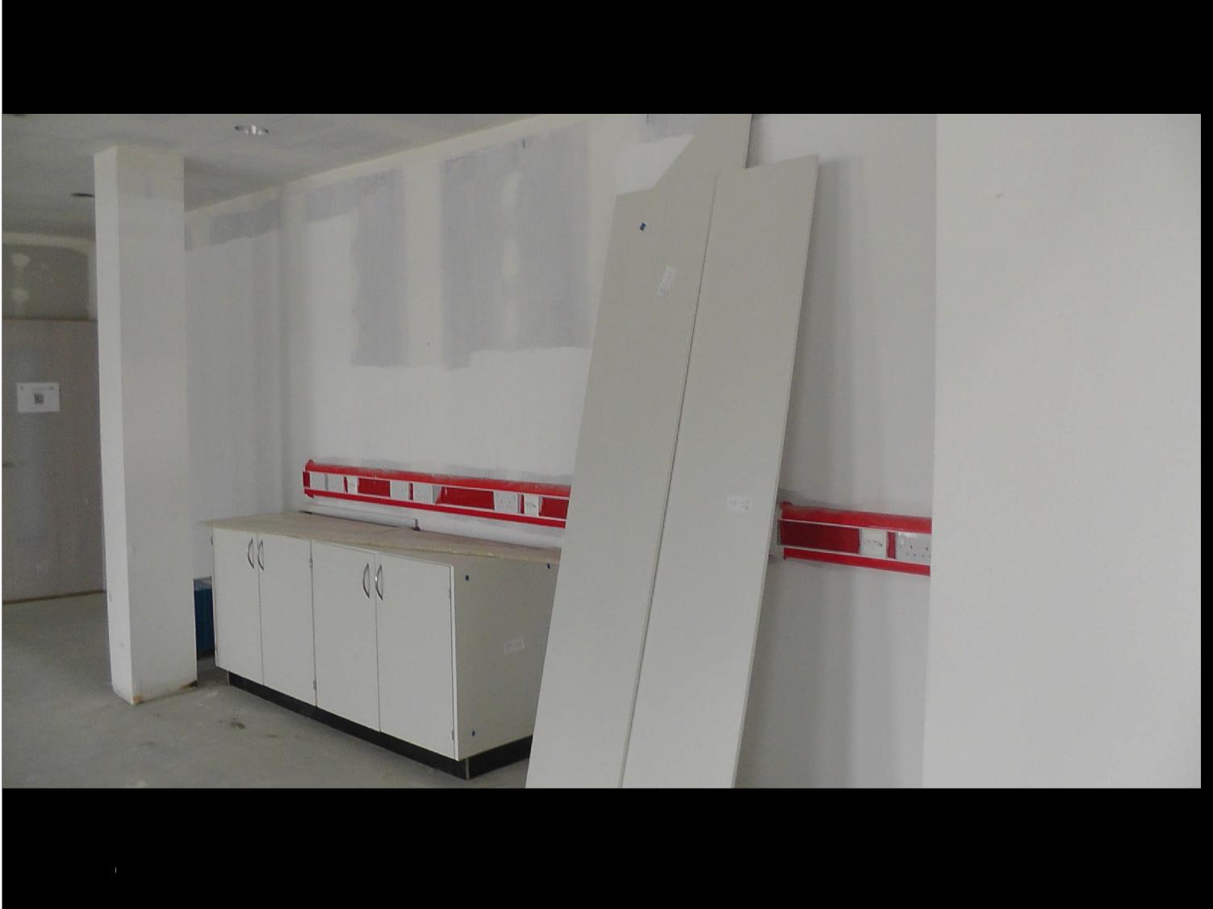

**Cabinets and Data and Power Sockets**

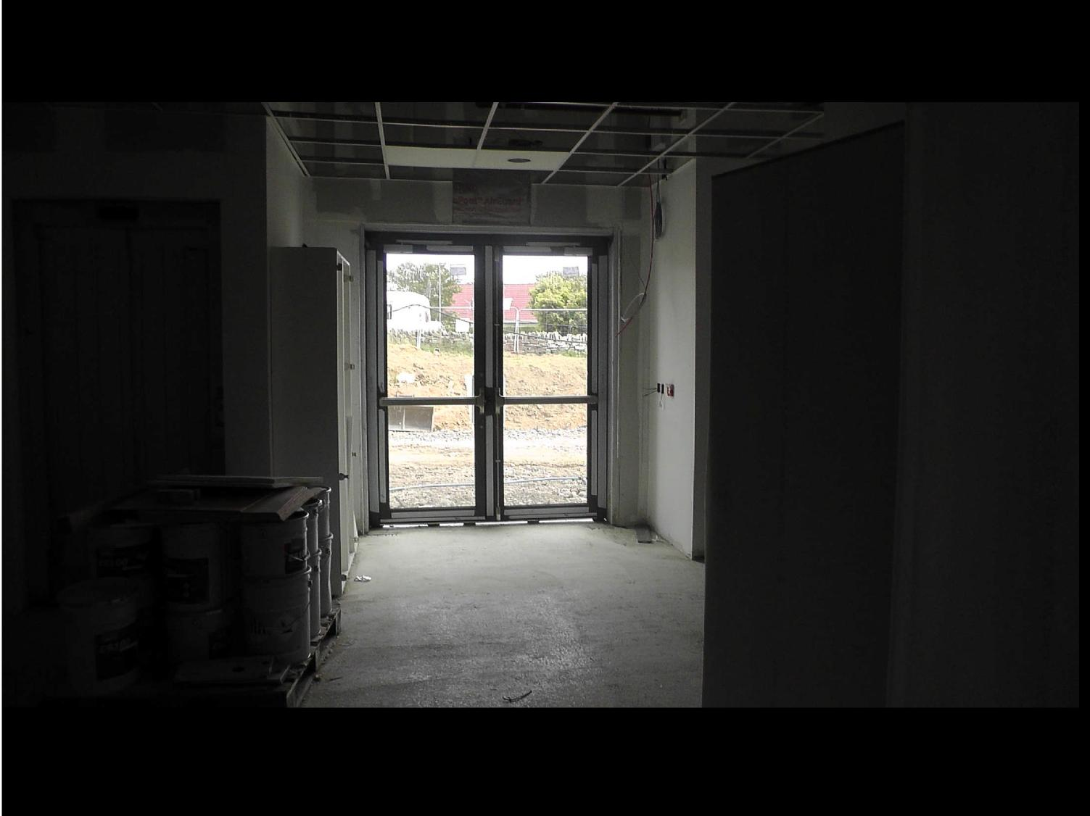

**Entrance to Clinical Support Building**

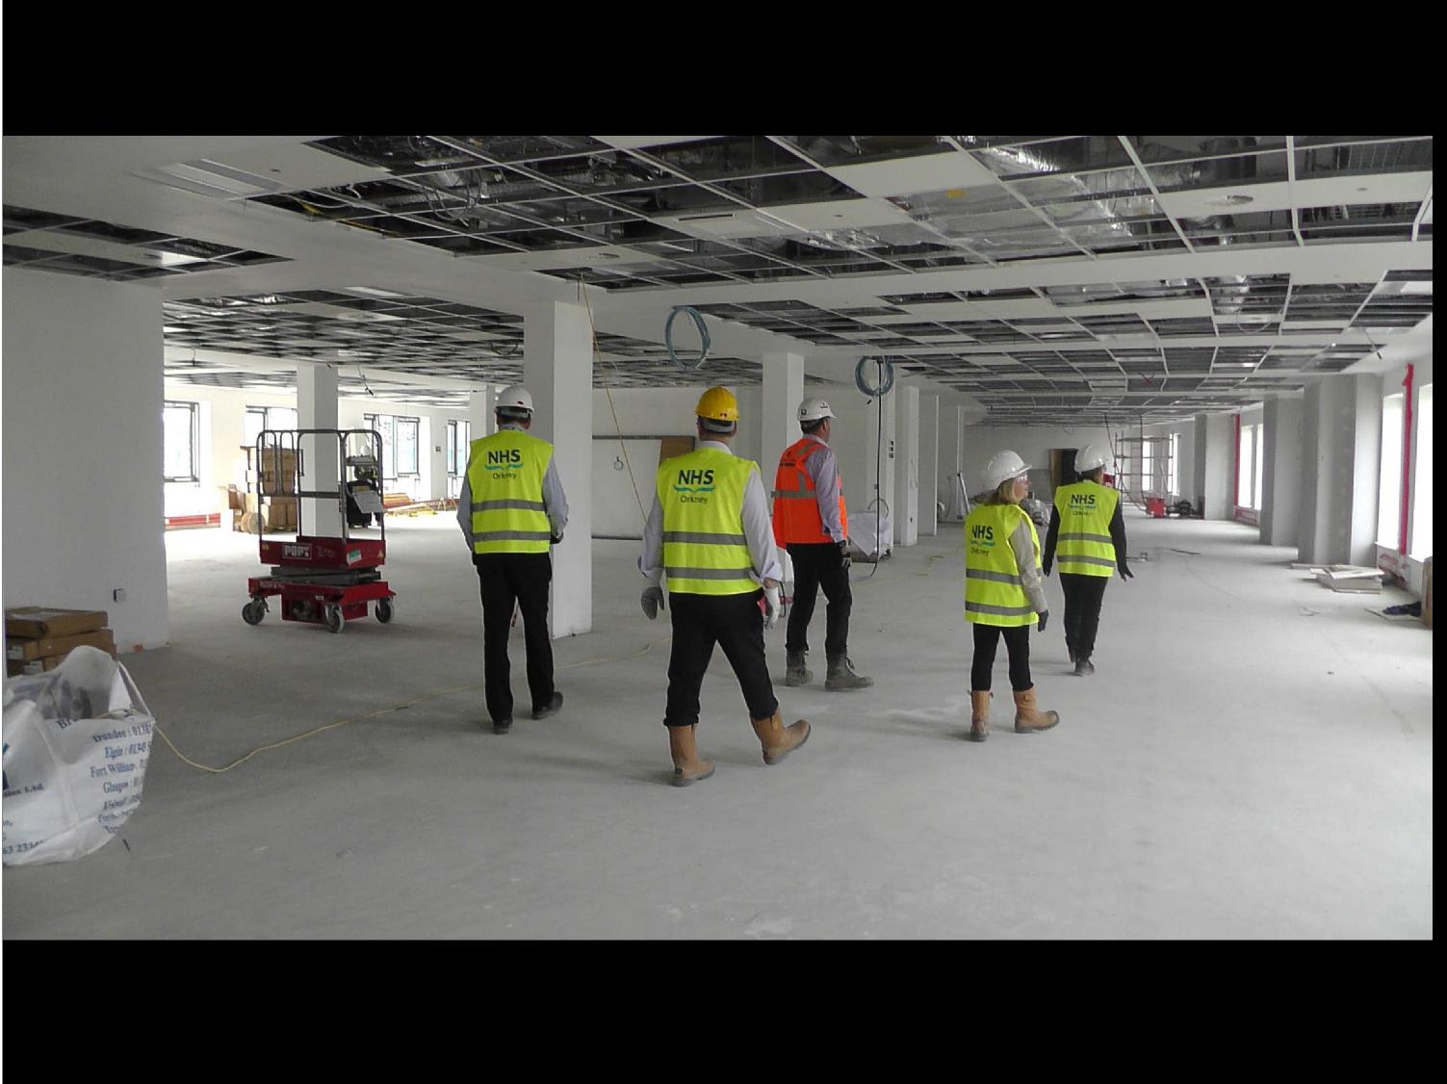

**Clinical Support Building - Open Plan Office Space**

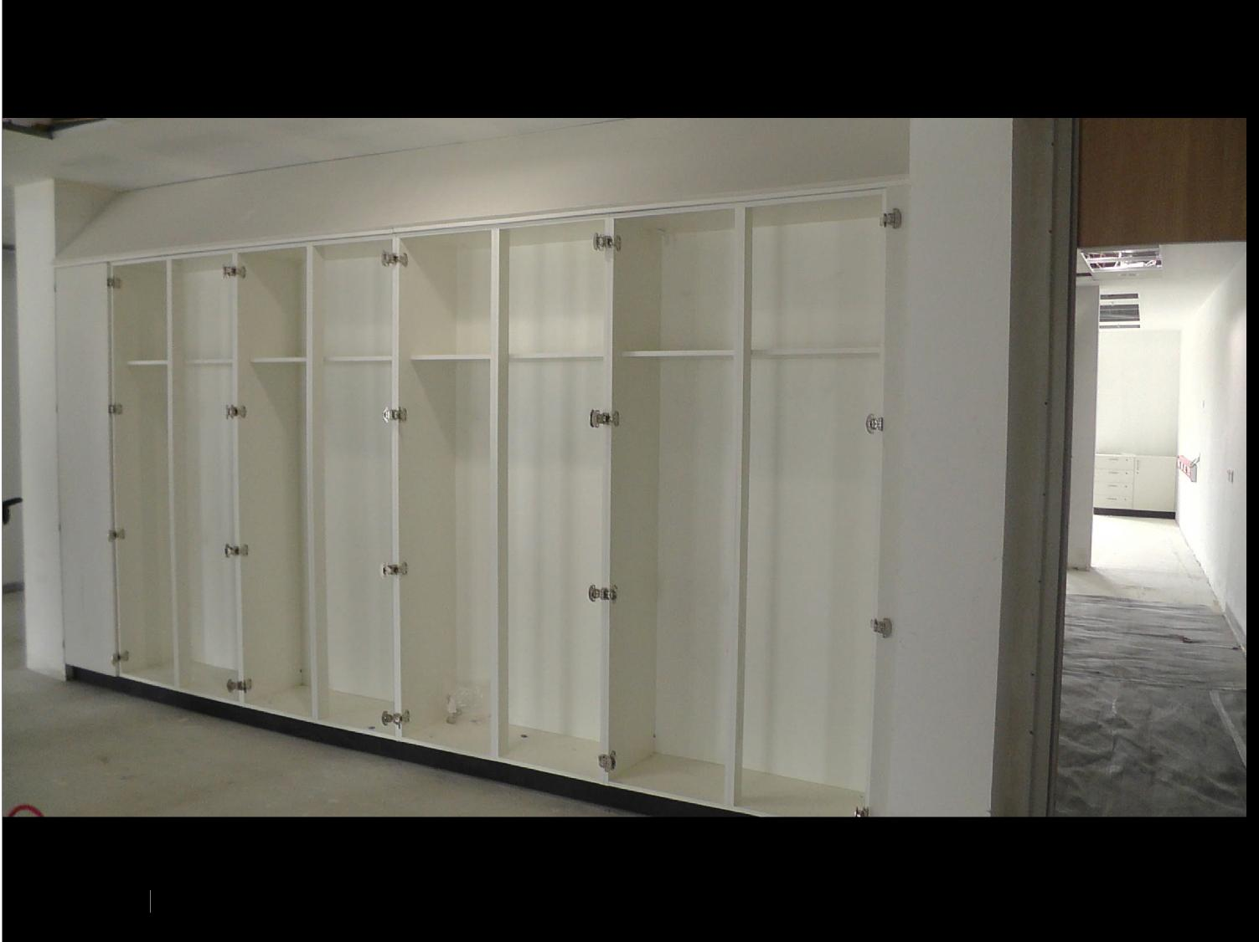

**Fitted Cupboards**

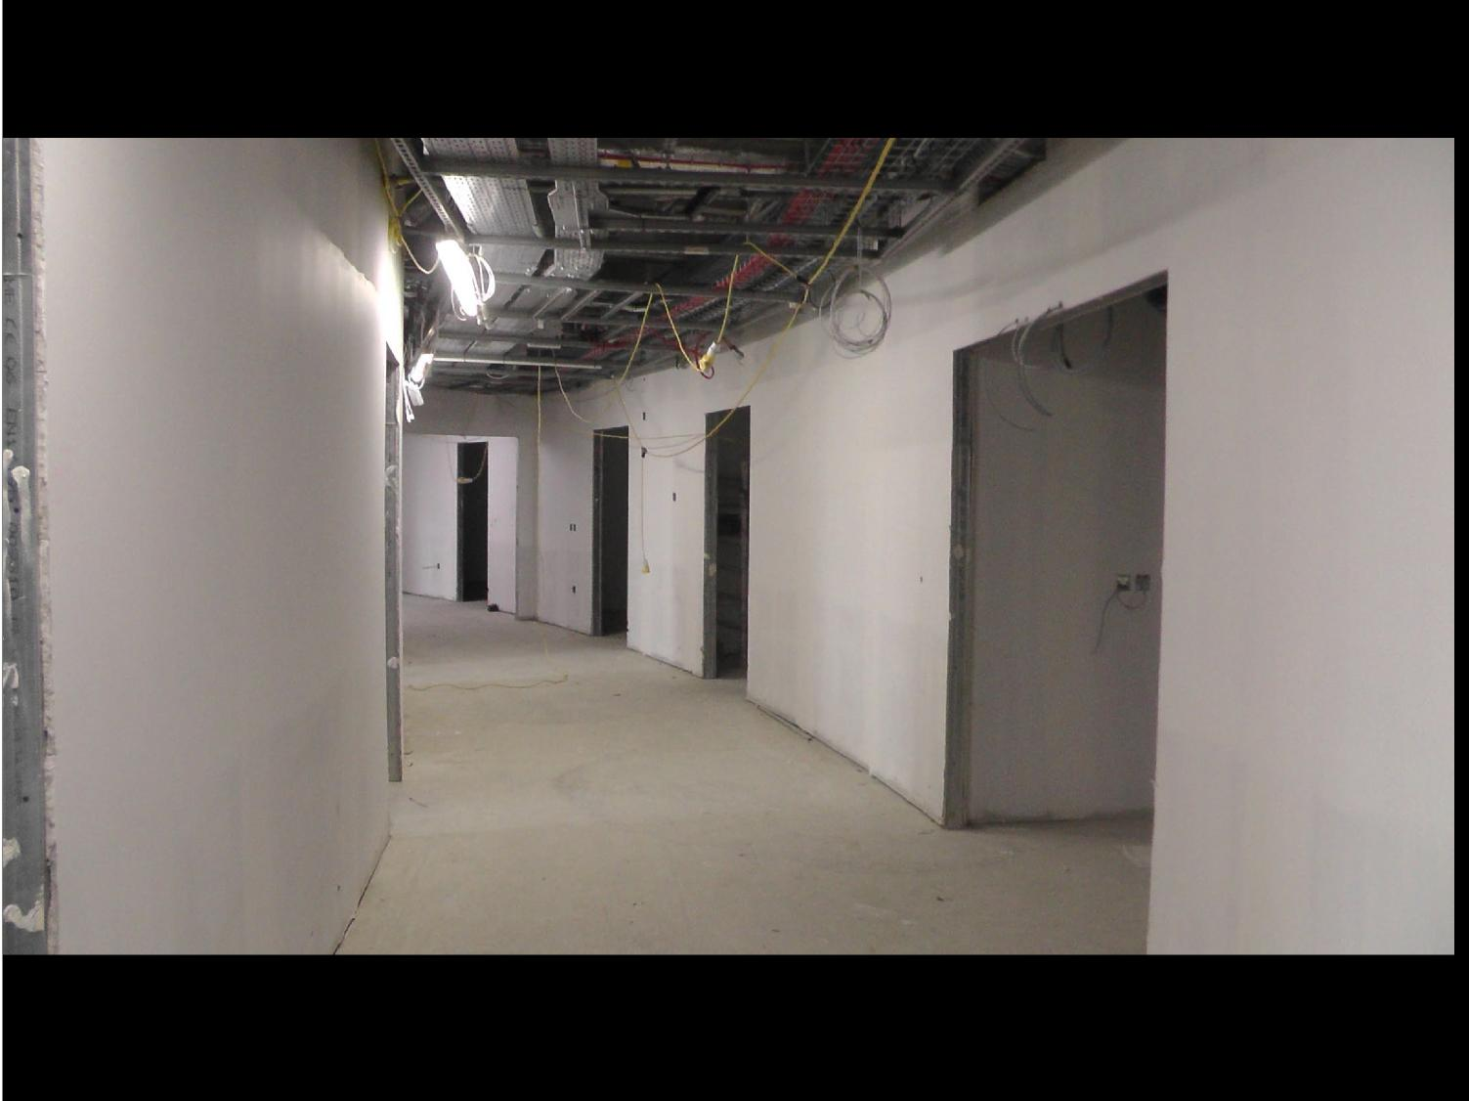

**Internal Corridor with Curve**

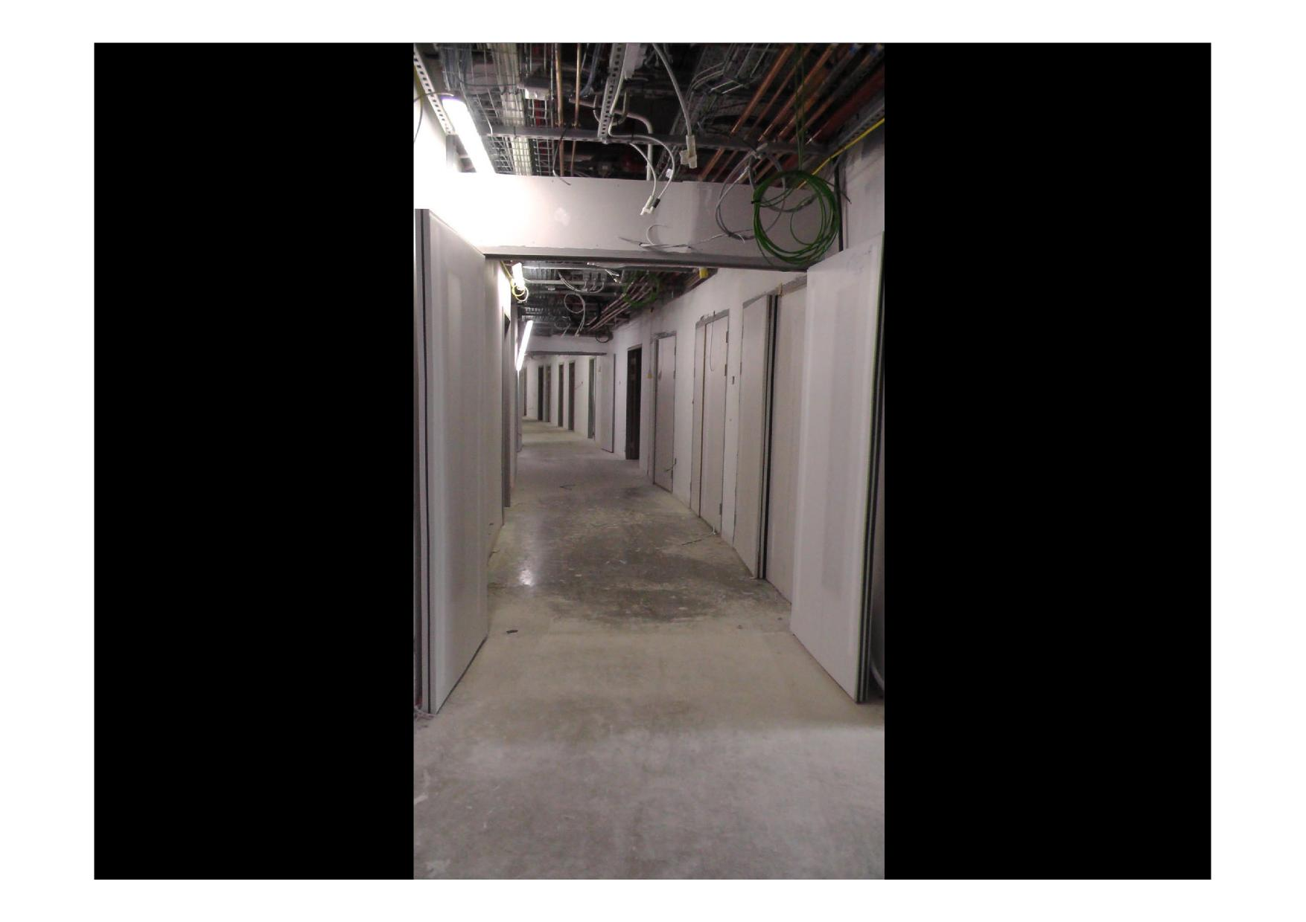

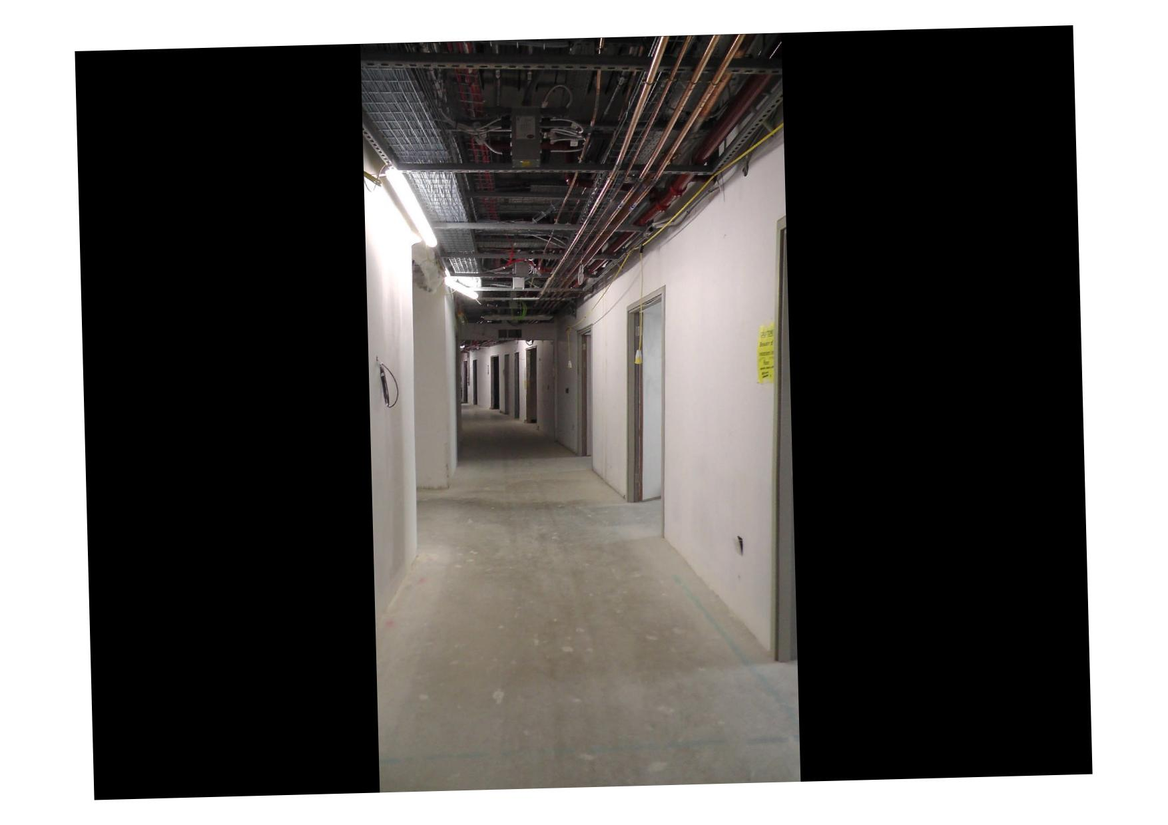

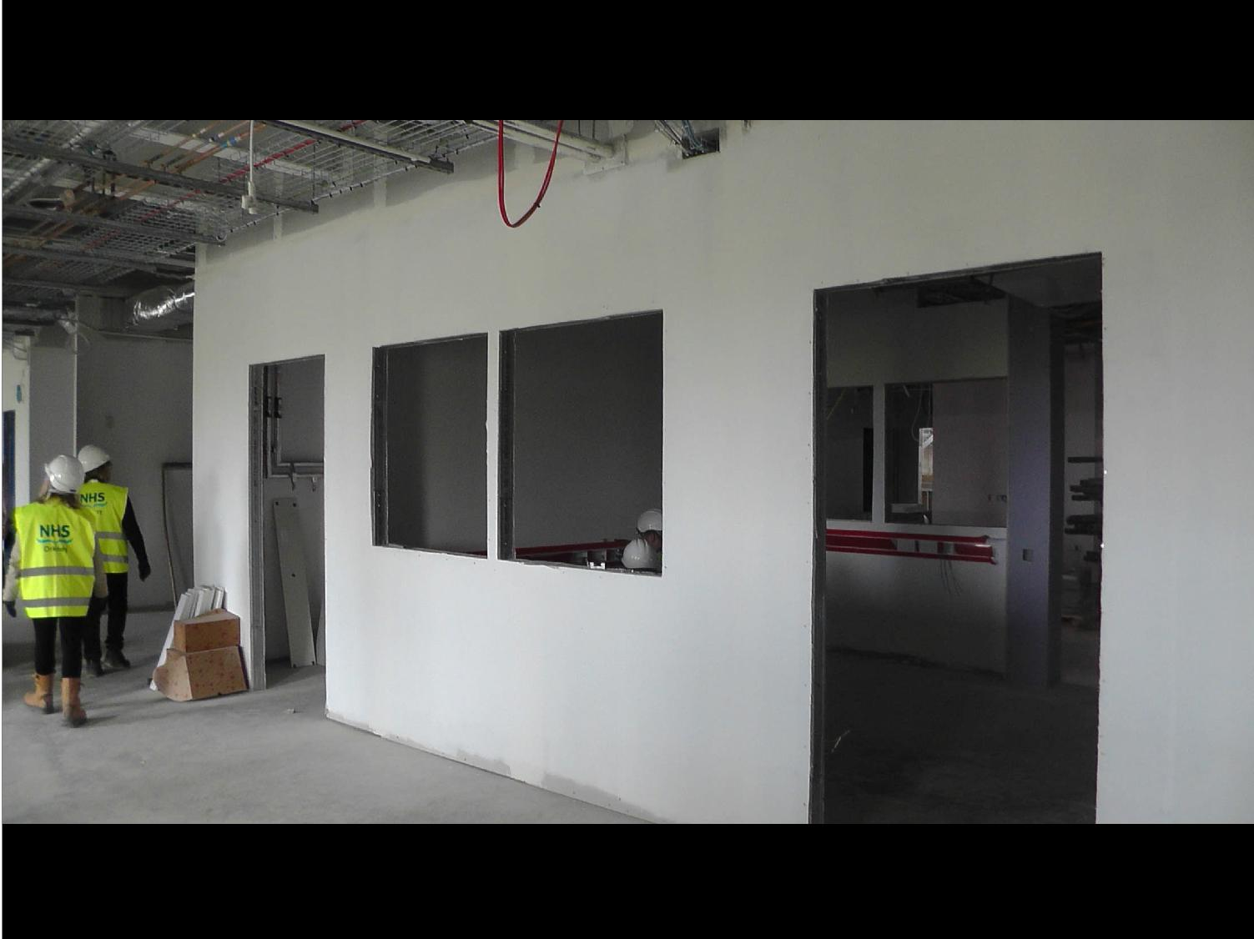

**Central Decontamination Unit**

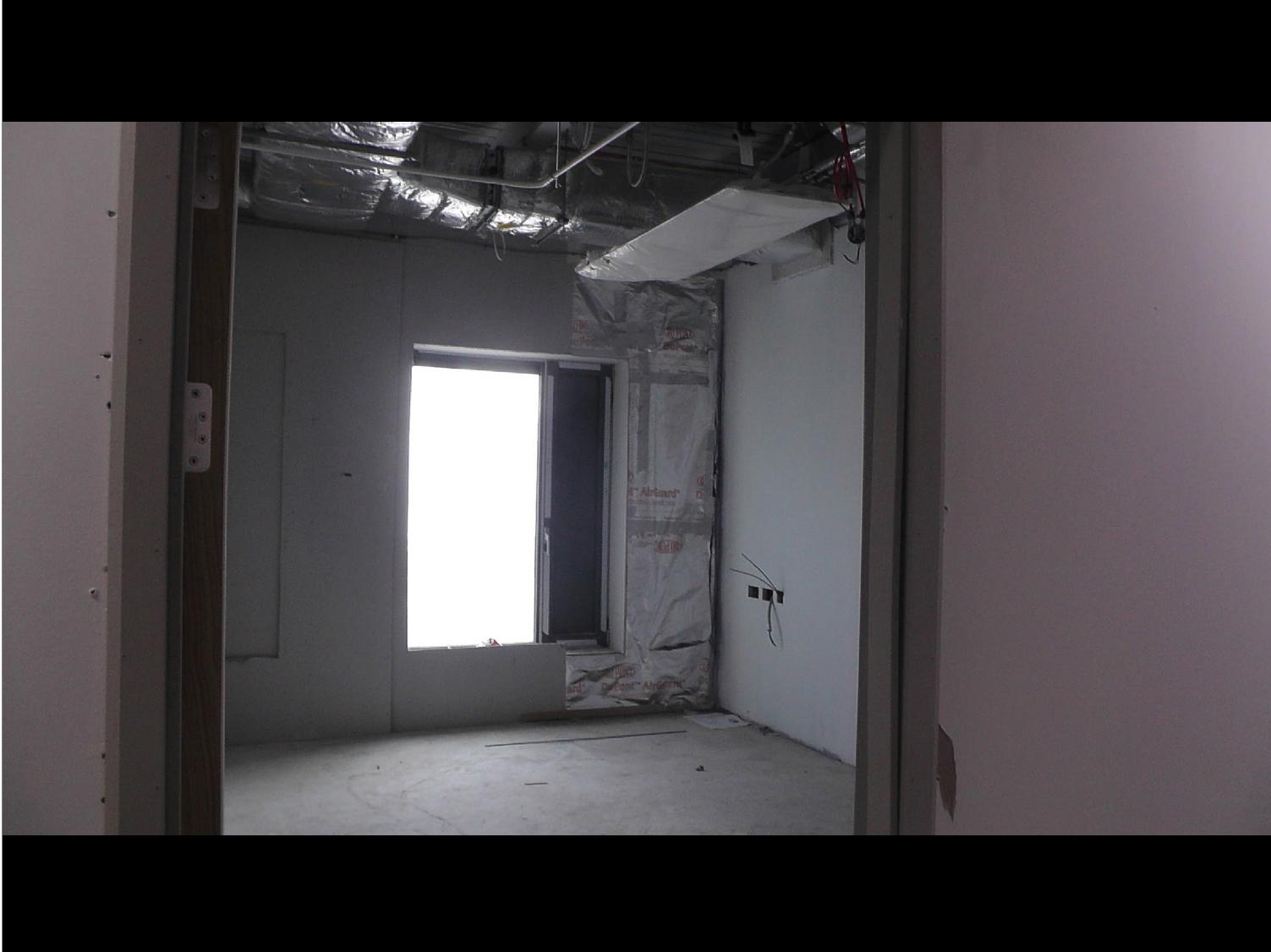

**Bedroom Window**

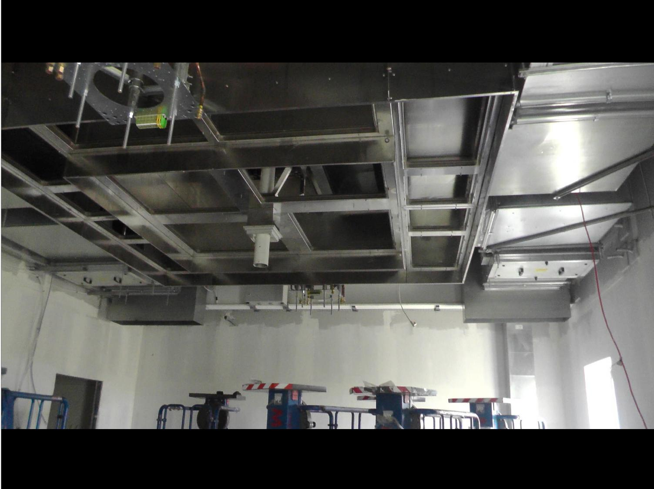

**Operating Theatre Ceiling Canopy**

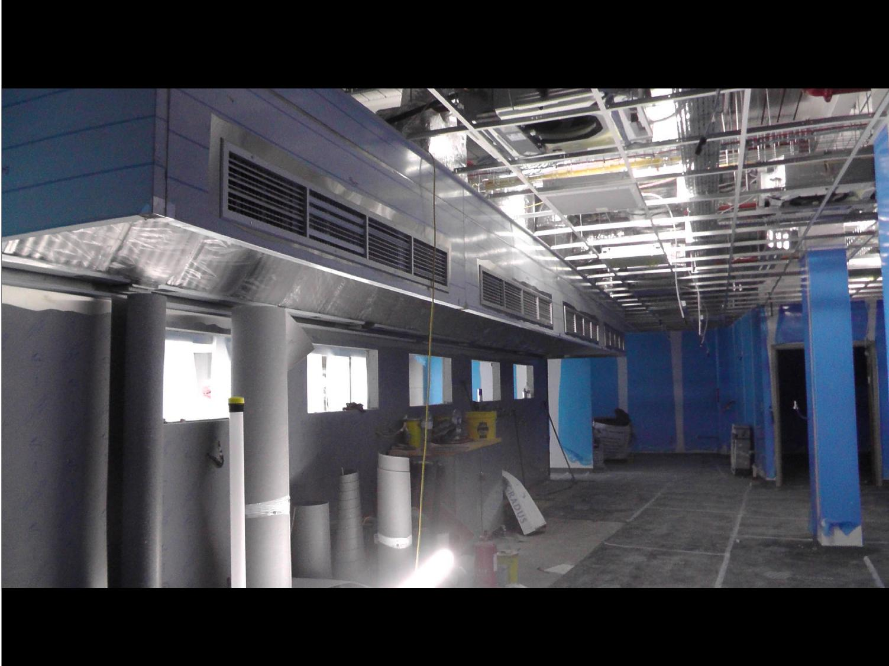

**Main Kitchen and Food Preparation Area**

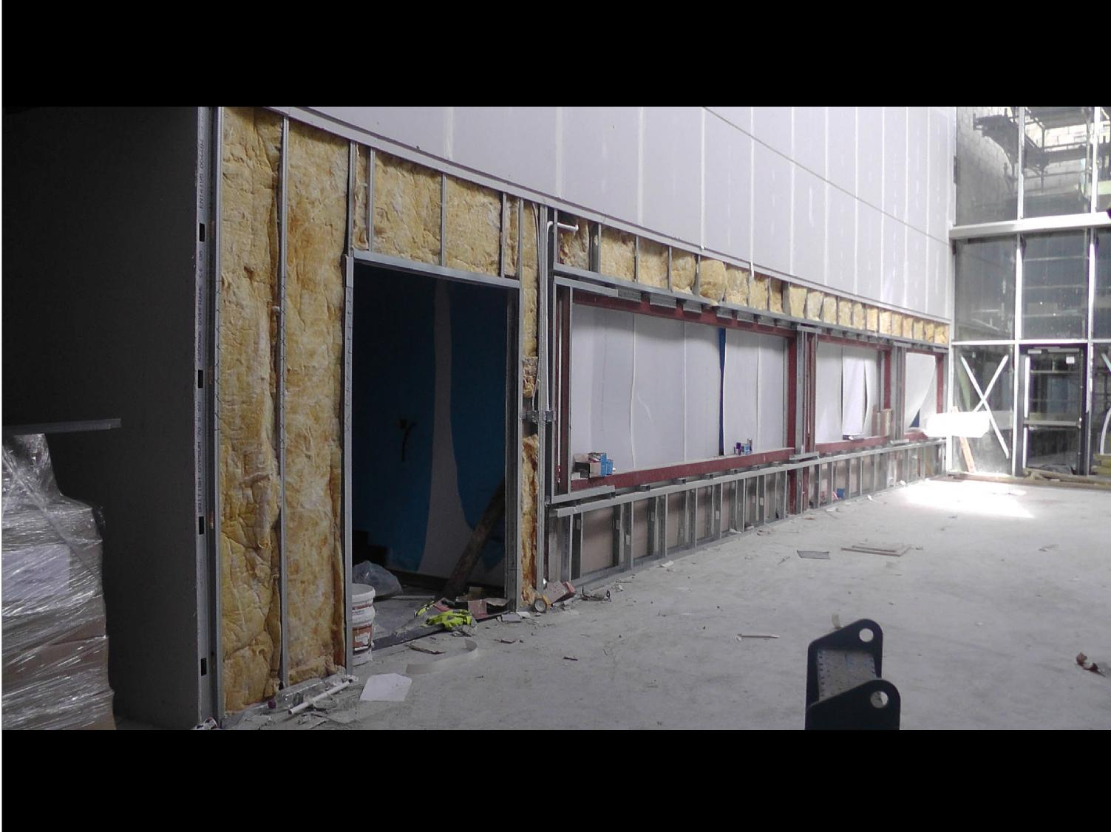

**Restaurant Servery Area**

|  |  |
| --- | --- |
| **Restaurant**  **Seating Area** |  |
|  |

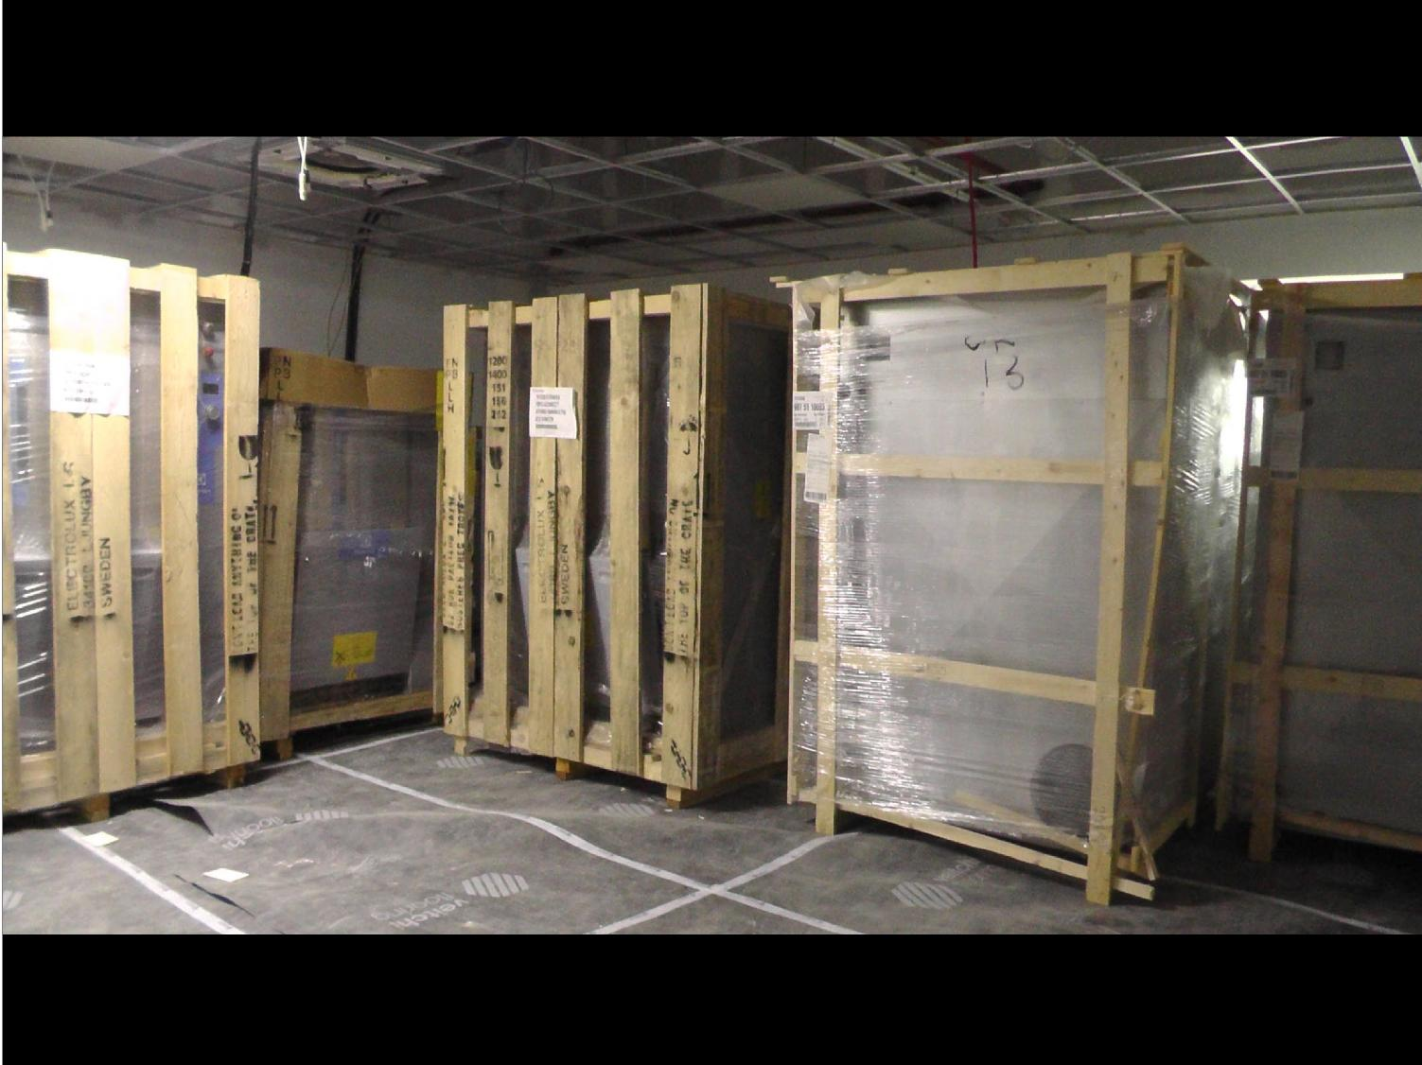

**Washing Machines and Dryers in Laundry Space**

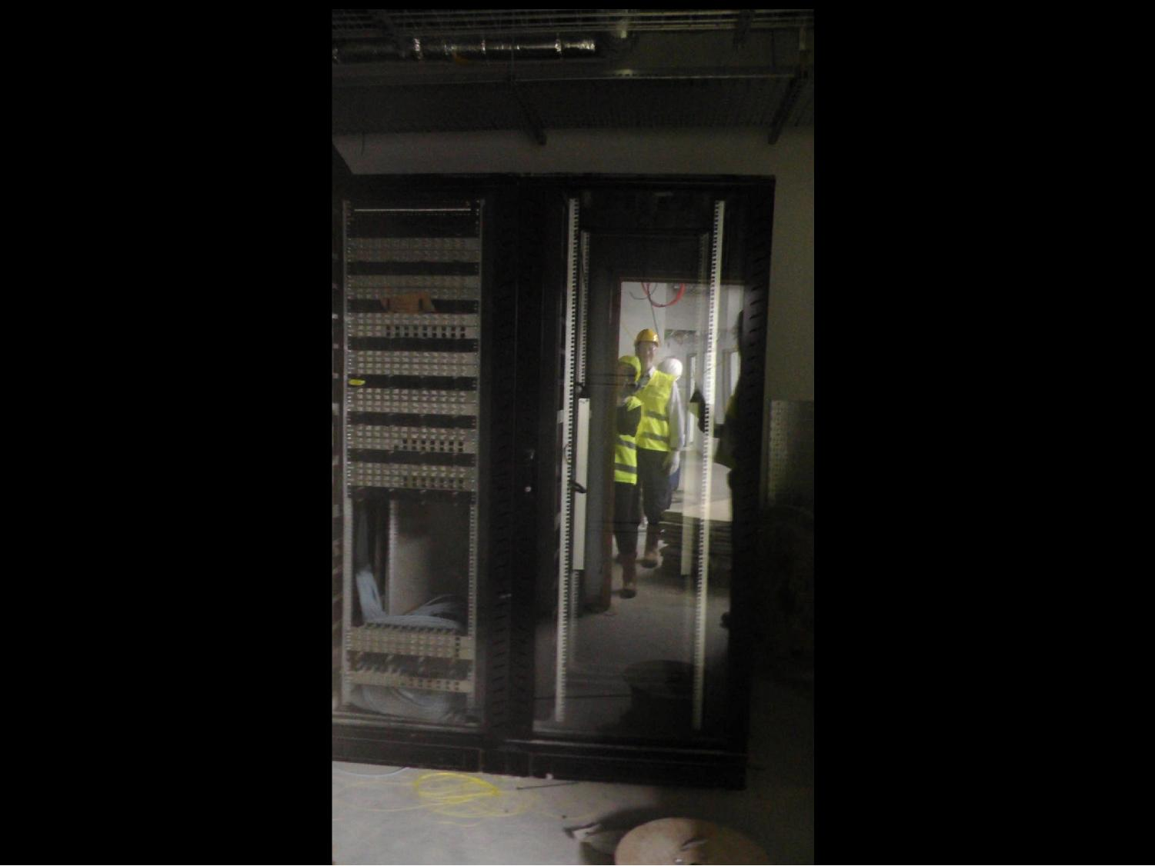

**Data Room with**

**Server Cabinet**

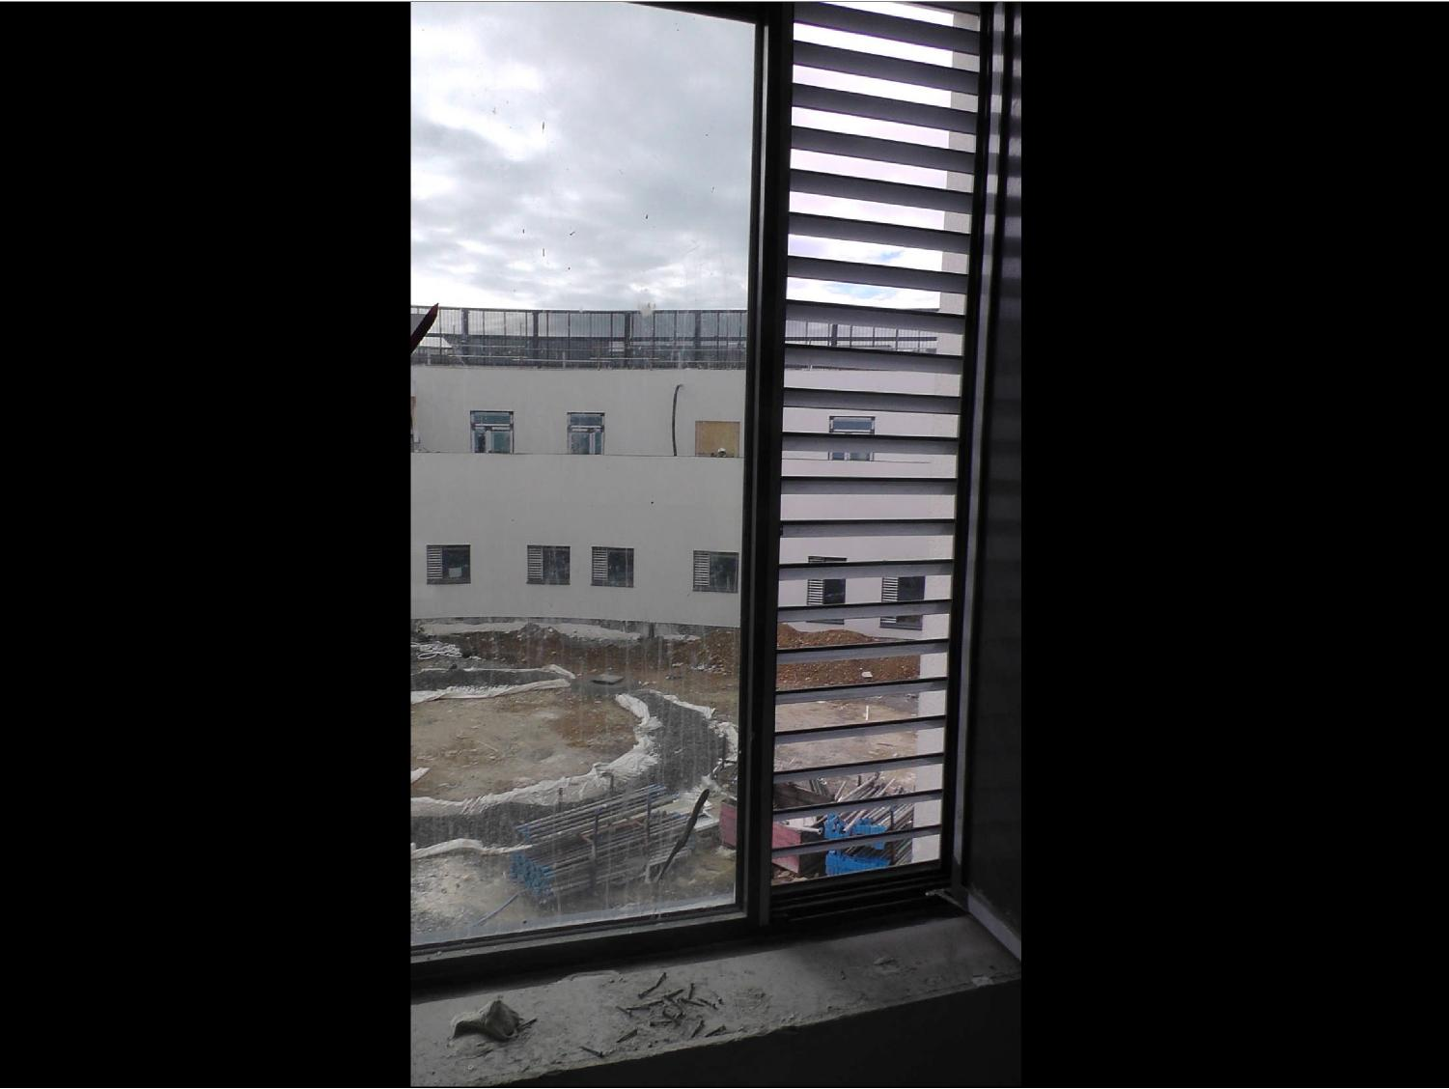

**View from**

**Bedroom to**

**Internal**

**Courtyard.**

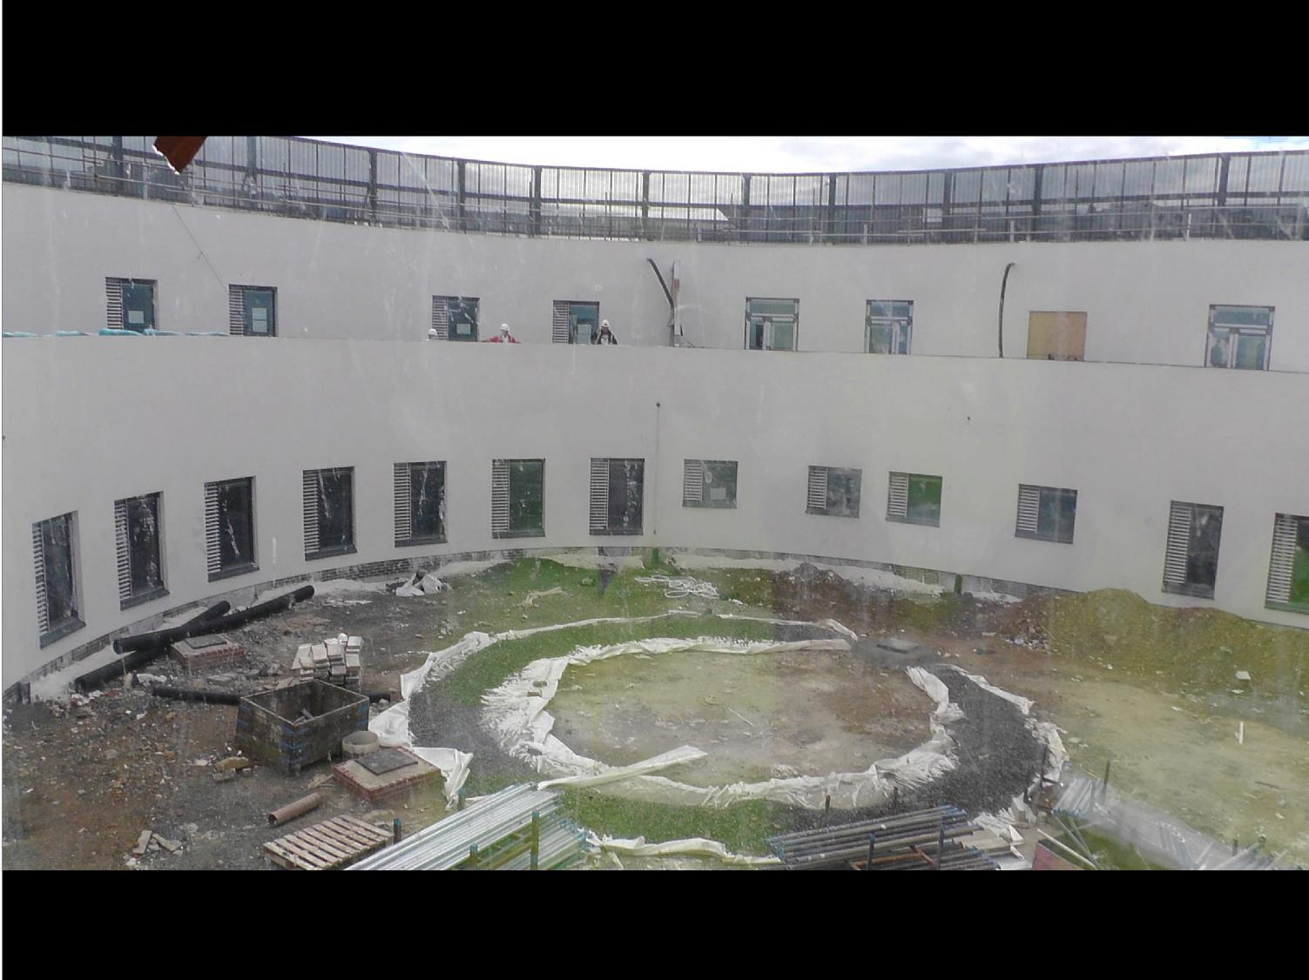

**Internal Courtyard Space**